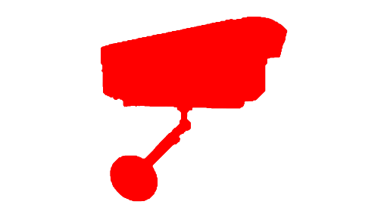

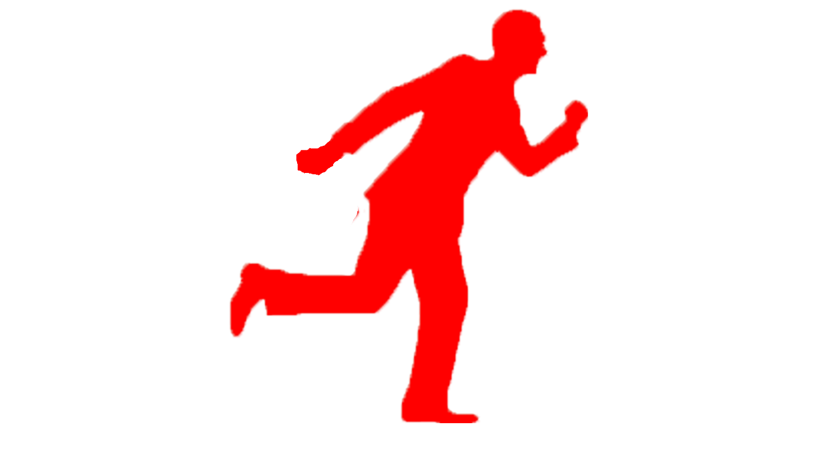

**ZEONIC**

**ALWAYS WATCHING!!**

**ABSTRACT OF THE PROJECT**

**EXECUTIVE SUMMARY –**

**Problem Statement:**

We have huge amounts of **video footage data**, which has been recorded in the video cameras from all around this city. In addition to that, by the help of this footage the law enforcers are be able to catch/identify the culprits or any susceptive behavior person in a crowd. But, the main problem with this type of process is, it takes **large amount of time** in order to search and watch the moves and the behavior of **one particular person in a huge crowd** of 1000 people or more.

**Solution Overview:**

Our solution aims to save the precious time of our user by **avoiding tiresome journey** involved in watching the **hours of the footage** of the moves and the behavior of the person. By the help of our automated software, we will be detecting the **different faces** of the persons who are present in the video and we will be **comparing these faces** with the **inputs** which are given by the user to the software and if any of the faces match the inputs given by the user then we are going to send a **notification or alert to the user** in the form of an **message**. In this way, our software is going to **decrease the time required in searching** and it will be able to **assist the law enforcers** and be able to catch the person within the time to **stop a disaster from occurring.**

**Technology Overview:**

Now coming to the **development part**, We going to build this software by the help of the **openCV library.** With this library, we will be able to **detect the face** of the persons in the video and then we are going to provide these faces to **our software.** In this software, we are going to pass **different parameters** like – the **tone of the person** is white, the color of the **shirt is black** and the person **wearing glasses** and etc. Not only this, we can also directly **pass the face of the person** to the software and it will **compare it faces present** in the video. After the video processing is done, the software will provide the **similar persons to the user**, which are based on the **input given by the user**. The user will receive a **notification on the phone** when the whole processing is done.

**Team Ezerka: (From VJIT)**

* **Ashfaq Nisar**
* **Vamshi Krishna**
* **Vinay Reddy**
* **Manasa Kunduru**
* **Manogna Rayasam**

**Contact: 8074420470, 6281650031**

**Email: Ashfaqnisar00@gmail.com , Ezerka.inc@gmail.com**